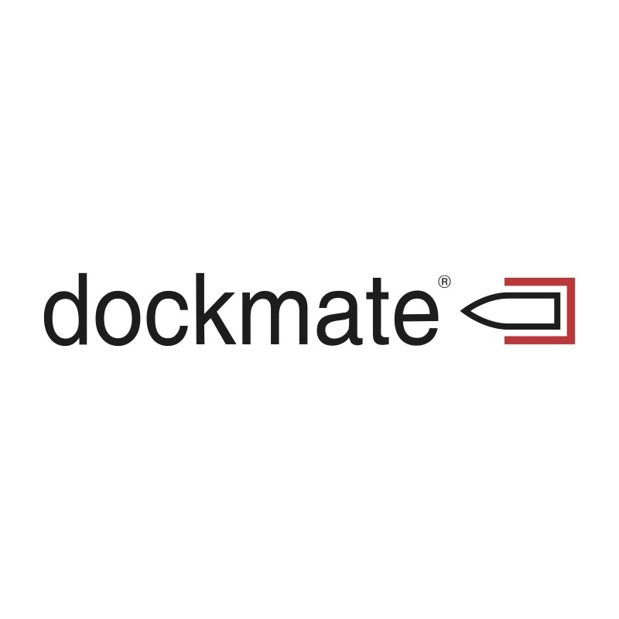

FOR IMMEDIATE RELEASE:  April 16, 2024 | Andrew Golden  Principal  Rushton Gregory Communications  617-413-6521  agolden@rushtongregory.com

DOCKMATE® ANNOUNCES COMPREHENSIVE SUPPORT FOR SLEIPNER THRUSTER SYSTEMS
Boortmeerbeek, Belgium – Dockmate®, leading manufacturer of advanced wireless remote controls for yachts, announced today full support for all Sleipner thruster systems and configurations, ensuring unparalleled maneuverability and control for yacht owners.
Dockmate’s seamless integration extends across Sleipner’s complete range of diverse thruster systems, which many people will know as “Side-Power” thrusters: from on/off to proportional; and from their DC electric thrusters, to their AC electric and hydraulic thrusters.
Dockmate’s support for proportional control of Sleipner's thrusters fitted with S-Link™ controls, means that users of a Dockmate TWIST or VECTOR remote can continue to control their thrusters proportionally, even when away from the helm. This feature ensures precise and smooth operation, granting skippers the confidence to maneuver their vessels in tight marina spaces or during challenging docking operations. In addition, Dockmate can be calibrated so that simply pushing the TWIST or VECTOR joystick sideways, will move the boat sideways.
Moreover, Dockmate's recently released ThrusterHold feature, which allows captains to maintain their thrusters engaged at a predetermined level to keep the boat pressed against a jetty, pier or another boat for simplified mooring, is also fully compatible with Sleipner's S-Link™ controlled thrusters. This functionality not only enhances docking safety and ease but also mirrors Sleipner’s commitment to integrating cutting-edge technology with user-friendly solutions. Skippers familiar with Sleipner’s own Hold feature will be sure to appreciate ThrusterHold when away from the helm.
“We are thrilled to announce our comprehensive support for Sleipner thruster systems, solidifying our position as a leader in remote control docking solutions,” said Dirk Illegems, President of Dockmate. “Our mission has always been to provide yacht owners with the most reliable, intuitive, and technologically advanced products on the market, offering unmatched control and flexibility to our customers. We are confident that yacht owners that have Sleipner thrusters will enjoy the peace of mind that comes from a Dockmate remote control system.”
“Making boating safer and more comfortable is very much in Sleipner's DNA. The integration of propulsion and steering systems onboard increases user-friendly operation with less stress for many boat owners,” said Thomas Skauen, Product Communication Manager at Sleipner. “It has been great working with the Dockmate engineering team to verify the system's compatibility with our full range of products. Sleipner offers the world's most comprehensive thruster program up to 160-feet, ensuring an optimal solution for most vessels.”
For more information on Dockmate and their wireless remote control systems, visit their website at www.dockmate.eu.

-30-

About Dockmate®:
Dockmate® manufactures the latest in advanced, yet very affordable wireless remote-control technology. Highly reliable and intuitive, the Dockmate SINGLE, TWIN, TWIST and VECTOR allow every skipper to dock a boat singlehanded, offering the ability to leave the helm and get a closer look at the surroundings in marinas and other tight quarters, while still in complete control of the boat’s movement.

About Sleipner Group:
Sleipner Group is a leading manufacturer of marine thrusters and stabilizers systems. Their products, previously branded under Side-Power, are renowned for their high quality, reliability, and innovation. Sleipner's commitment to excellence has made them a preferred choice for the majority of boat builders and owners worldwide.

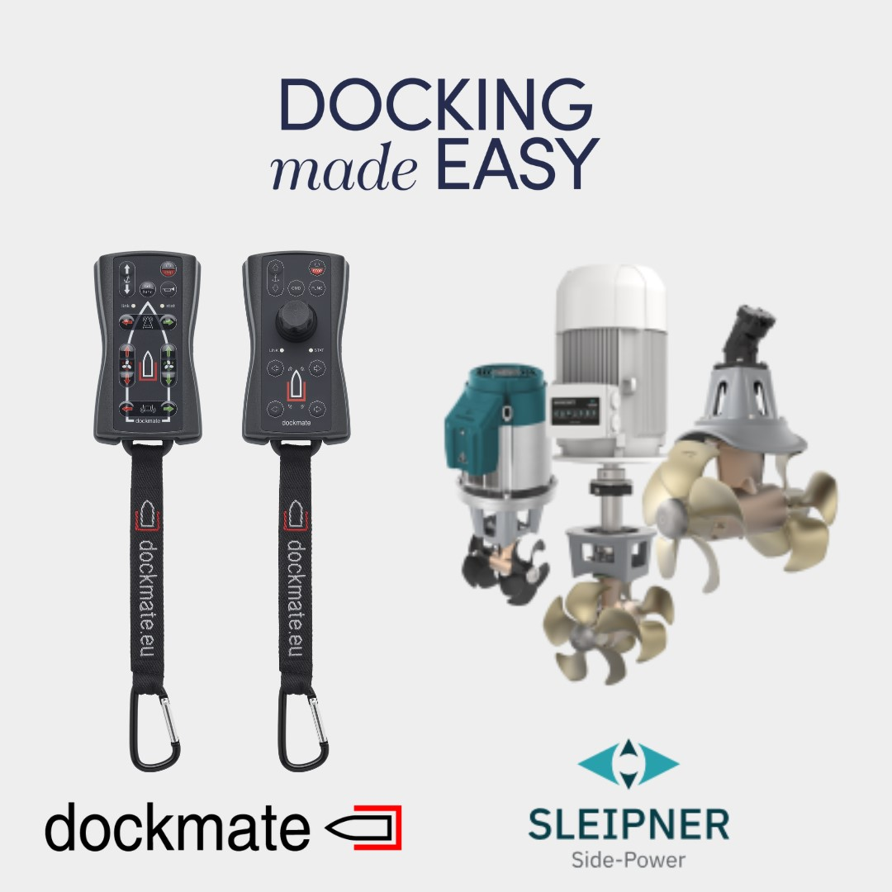

For hi-res images, as well as additional editorial requests, please contact:

Andrew Golden
Rushton Gregory Communications
agolden@rushtongregory.com

